 

**MIDDLE EAST TECHNICAL UNIVERSITY**

**DEPARTMENT OF ELECTRICAL & ELECTRONICS ENGINEERING**



**Potato Integrated Technologies**

**Critical Design Review Report**

**Project: Devices Trying to Score in Each Other’s Goals**

**Duration: 01/10/2018 – 01/06/2019**

**Estimated Cost: $200**

**Design Studio Coordinator: Arzu KOÇ (Section 5)**

|  |  |  |  |  |
| --- | --- | --- | --- | --- |
| **COO**  İrem COŞKUN  2030419  +90 539 414 5969 | **CMO**  Berkay  GÖKSU  2030757  +90 505 635 8145 | **CTO**  Furkan Bahadır  ELİK  2030518  +90 554 963 9410 | **CEO**  Fatma Nur  ARABACI  2030047  +90 533 602 7527 | **CFO**  Aycan  BEYENİR  2030328  +90 539 330 0570 |

Table of Contents

1 Executive Summary 1

2 Introduction 2

3 Overall System Description 3

3.1 General System Description 3

3.2 Individual System Description 3

3.2.1 Power Supply Subsystem 3

3.2.2 Communication and Telecontroller Subsystem 4

3.2.3 Shooting Subsystem 8

3.2.4 Motion Subsystem 10

3.2.5 Detection Subsystem 14

3.2.6 Main Processor Subsystem 15

3.3 System Level Block Diagram & Flowchart 18

4 Requirements 20

4.1 Overall System Requirements 20

4.2 Subsystem Level Requirements 22

4.2.1 Power Supply Subsystem Requirements 22

4.2.2 Communication and Telecontroller Subsystem Requirements 22

4.2.3 Shooting Subsystem Requirements 23

4.2.4 Motion Subsystem Requirements 24

4.2.5 Detection Subsystem Requirements 24

4.2.6 Main Processor Subsystem Requirements 25

5 Design Modifications and Justifications 25

5.1 Power Subsystem 25

5.2 Telecommunication Subsystem 26

5.3 Shooting Subsystem 27

5.4 Motion Subsystem 27

5.5 Detection Subsystem 27

6 Compatibility of subsystems 28

7 Test Procedure 29

7.1 Power Supply Subsystem 29

7.2 Telecommunications Subsystem 29

7.3 Shooting Subsystem 30

7.4 Motion Subsystem 30

7.5 Detection Subsystem 31

7.6 Main Processor Subsystem 31

8 Compliance with Requirements 32

8.1 Design Decisions and Requirement Correlations 32

8.2 Conflicting Requirements and Trade-offs 33

8.3 Discussion on Robustness 33

9 Resource Management 34

9.1 Cost Analysis and Breakdown 34

9.2 Power Distribution Analysis 36

9.3 Gantt Chart 39

10 Conclusion 40

11 References 41

# Executive Summary

This report presents details of the project for a teleoperated robot trying to score in opponent’s goal and defend its own meanwhile. Remotely controlled robots are widely used in many aspects of our life. Main idea behind this project reflects a real-world problem in occasions where the user has no view of the robot. Therefore, a two-way communication with the robot and user’s computer should be established. Reliability and efficiency of this communication is vital since intervening a distant robot which can be unreachable at that instant, by the user can be challenging.

This design will be accomplished by building an efficient communication, a robust mechanical design and reliable electronic system. We aim to achieve satisfactory performance in speed and accuracy. Our final product is to detect the ball on the field, shoot the ball towards the opponent’s goal, defend its goal and stay in its half field doing so. Several solution methods are sufficiently described in the following sections of this report.

Our company is composed of five shareholders with different specialization fields and backgrounds. Therefore, each team member came up with a solution from a different point of view. We merged these perspectives in order to construct solution approaches at this point of our design process.

Mission of our company is to provide creative and reliable solutions that fulfill the needs of industry in the field of Industrial robot applications while or vision is to become the most compelling technology company by driving the Industry’s transition to smart manufacturing.

Even though our base knowledge is similar, each team member chose to study in different fields. Therefore, at certain levels of the design process and solution offering, each member has a different idea and experience. Ms. Arabacı is more experienced in controller design and system modelling which will help her to guide and inform the team, Ms. Coşkun and Mr. Göksu will lead the team with their programming skills. Mr. Beyenir’s knowledge in electronics will help us in the integration stage and last but not least Mr. Elik will take an active role in building a durable and stable communication system.

Final product will be delivered in best way with a cost of 200$, at the end of 7 months by PITECH engineers. Once the customer purchases the final product, they will own the final action robot consisting of mechanical subsystems, camera, sensors and drivers. In addition to these, a user manual, a warranty document, required software tools, four batteries, battery chargers, three game field walls, two balls (one is extra) and a dummy robot are also provided.

# Introduction

In the last few decades, robots are gaining more complex abilities, thanks to improvements of technology, that they substitute for humans in many fields of industry. This progress enables us to handle things easier and, in more time, efficient way since their performance is better than ours in many aspects of our daily life such as personal, professional life etc.

Being a newly founded company with five highly motivated, young engineers from different specialization fields such as electronics, control, computer and telecommunications; our aim is to develop a teleoperated robot that can play hockey which includes trying to score in opponent’s goal and also defend its own goal. Apart from the specifications defined above we intend to come up with the best featured robot possible.

In this project, our main purpose is to build a robot that we can control from a specified distance with a remote controller. Also, this robot should be controlled without actually monitoring the play-field with naked eye; the only means of monitoring the field is by means of a camera mounted onboard the robot. Wi-Fi connection is not allowed for transmission, that is the reason why we are using RF communication to transmit the data. In addition to that, the robot is not allowed to cross the center-line into opponent’s half-field. Another requirement is that the ball must be transferred to opponent’s half-field in no more than 20 seconds.  Robots can hit, push or otherwise drive the ball but not grasp, scoop or otherwise carry it.

In order to fulfill these requirements, we found an efficient way to transfer data from our robot to the main computer so that we can improve our chance to score a goal and win the round. This is a two-way communication since we will send directions to the robot so that it can move with respect to these commands. In addition, the mechanical structure of the robot should also be robust so that it can endure possible encounters with the ball. While developing the design, it should be noted that both mechanical and electrical solutions support each other. To sum up, this project and its solutions may contribute to the areas where teleoperated robots are used for many different purposes.

In this report, a detailed analysis of this project is presented. Description of overall system and subsystems is presented in this report. In addition to that, drawings, block diagrams, flow charts, test results, cost analysis, time plan can be found in following sections of this report.

# Overall System Description

## General System Description

In this project, we created a robot which is controlled by a remote user using a telecontroller. The robot is able to play hockey game within the standarts declared in last semester. Our robot contains different subsystems corresponding their functions, power supply, telecommunication, shooting, motion and detection.

## Individual System Description

### Power Supply Subsystem

#### 3.2.1.1. Solution Approach

This subsystem is for distribute power towards other subsystems at required voltage level and with specified current limitations. The power subsystem is composed of 2 LiPo batteries. As is known, our project consists of 2 separate parts which are controller side and robot side. Controller has “3s 900Mah LiPo” and the robot has “3s 2900Mah LiPo”. Both sides uses LiPo for supplying power to Arduino’s and other subsystems’ components. In Figure 3.1., the one Li-Po cell can be seen.



Figure 3.1 Example of 3 cells Li-Po Pack [1]

The motor draws a much higher current at maximum 2A. Connecting directly with Arduino will result in not working motor and destroying Arduino due to high currents. Hence, we used L298N Motor Drivers for supplying this current with Li-Po cells. The models can be seen in Figure 3.2.

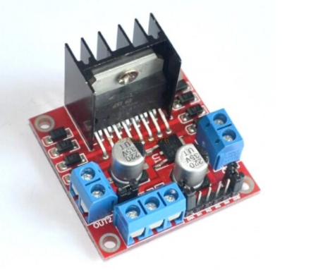

Figure 3.2 L298n dual motor driver [2]

#### 3.2.1.2. Block Diagram

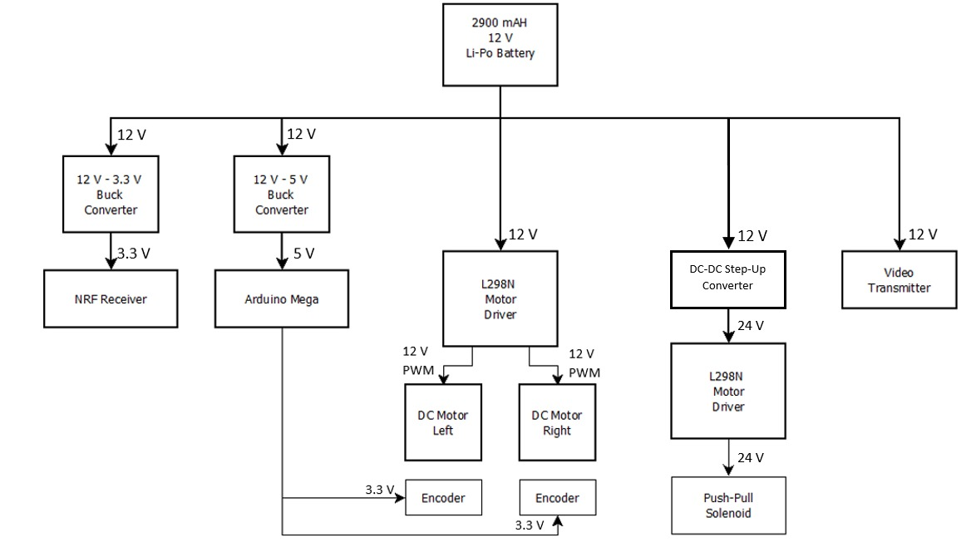

Figure 3.3 Block Diagram of Power Supply System

### Communication and Telecontroller Subsystem

#### Communication Link for Sending Commands

As a company, we see the telecommunication system as the main design objective of this project. For this purpose, we developed unique communication link for sending commands to a remote location which will become the robot later.

##### The Algorithm

In this communication link, we utilized an RF tranciever module, NRF24L01 and Arduino development boards for both the transmitter and receiver. In the controller side, the command from the user is taken with a joystick. Then the joystick position is read by an Arduino Uno. Then using SPI serial interface, the generated command signal is sent the RF module and finally the RF signal is sent the antenna. At the receiver side, the robot, the same NRF24L01 module receives the RF signal and again using SPI serial interface, the received signal is sent to the Arduino Mega. Then, the received signal is interpreted via Arduino and the respective command is decided. Afterward, the command is executed. . For better understanding, a simplified functional block diagram of the communication link for sending commands is given in Figure 3.4.

We used a 5 bit register to describe different commands. Whenever an assigned bit is 1, the corresponing command is sent via NRF module as 5 bit register. Bit sequence can be seen in Table 3-1.

Table 3‑1 Bit sequences for each individual command

|  |  |  |  |  |
| --- | --- | --- | --- | --- |
| Shoot | Forward | Backwards | Right | Left |
| 10000 | 01000 | 00100 | 00010 | 00001 |

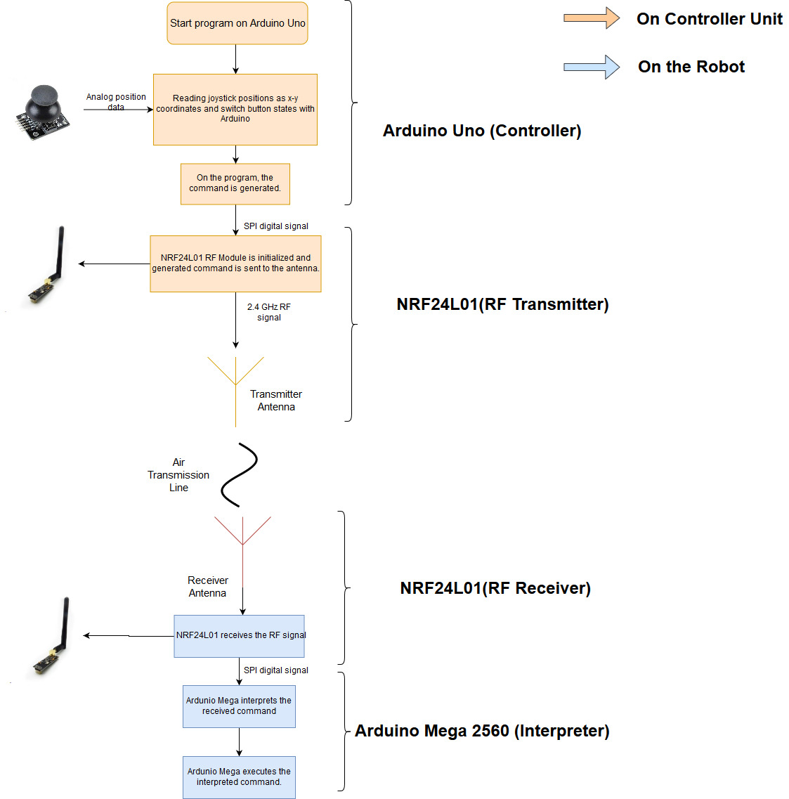

Figure 3.4 Block Diagram of the telecommunication subsystem for sending commands

##### Joystick (User Interface)

To receive commands from the user, we implemented a joystick which is composed of two potetiometers and a push button. Depending on the position of the joystick nipple, an analog signal is generated from the potentiometer and then this analog signal is received at the Arduino Uno. This part completes the user interface of the controller subsystyem. A photo of the joystick can be seen in Figure 3.5..

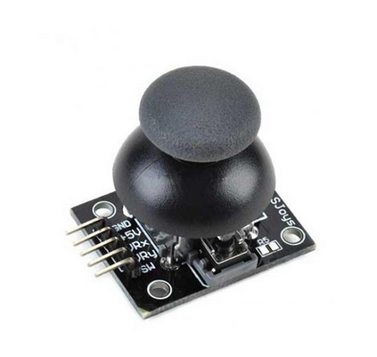

Figure 3.5 The joystick

##### Arduino uno (Controller)

On the Arduino, depending the analog signal values from the joystick, the bit sequence is generated (explained at the algorithm part). The program on the Arduino controls the RF tranciever module, NRF24L01, and writes the bit sequence values to the module. We used RF24.h and nrf24l01.h libraries to control the module.[3]

##### NRF24L01 (RF Tranciever)

To send the bit seqeunces that carries the command information, we used NRF24L01 module which uses 2.4 GHz RF signal to communicate (Figure 3.6). This module can be used as both transmitter and receiver. On the controller side, the module is used as only transmitter and on the robot side, the module used only as receiver. The selection between transmitter and receiver modes are declared in the program code.

The modules come with an dipole antenna. However, the antenna can be replaced. 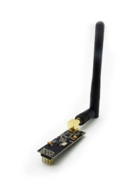

Figure 3.6 NRF24L01 RF Module

After sending and receiving the message from the NRF24L01, the message is transmitted to the robot and ready to be interpreted at the Arduino Mega which is located at the robot.

##### Arduino Mega 2560 (Interpreter)

After the signal is received by the NRF24L01 module, the signal with command infformation is sent to the Arduino Mega, where the signal is interpreted and the command is decided. In the code, the received bit sequences are compared and matched to the commands. Basically, this is the exact reverse operation of the controller side.

After successfully interpreting the received command, Arduino Mega controls the motion and shooting subsystems by sending respective PWM control signals to the motor drivers.

### Shooting Subsystem

#### Solution Approach

The electrical energy stored in the batteries must be transformed in mechanical energy to move the ball. In this system which is solenoid actuated, self-inductance is used. A current is send through a coil which generates a magnetic field. This field can be increased by increasing the number of windings of the coil or by increasing the current through the coil. With this magnetic field, a ferromagnetic material can be attracted or repulsed. The shooting mechanical system design can be seen in Figure 3.7..

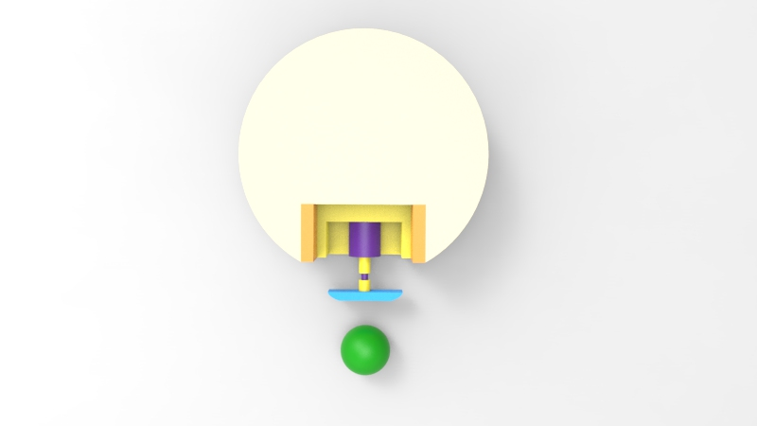

Figure 3.7 Top view of shooting mechanical system design

When a current is sent through a loop of a wire, a magnetic field is built. A solenoid is based on this principle, shown in Figure 3.8. It contains a lot of loops of wire, forming a coil, producing a magnetic field when an electrical current is sent through it. The plunger is used to provide a mechanical force which will be used to kick the ball. The force applied to the plunger by the coil is proportional to the change in current, radius and length of the coil. Also, we used striker plate which increases the surface are of the kicker, increasing the chance of it making contact with the ball[4].

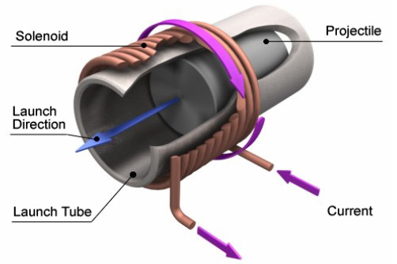

Figure 3.8 A schematic representation of a solenoid [5]

Also, the working principle for how to drive solenoids with Arduino can be seen in Figure 3.9. This schematic is given by supplier with some notes. These are:

1. You will most likely need a heat sink on the transistor.
2. This diagram is for DC solenoids rated up to about 24W: i.e. 12V@2A, 6V@4A etc.
3. The protection diode should preferable be a Schottky type.

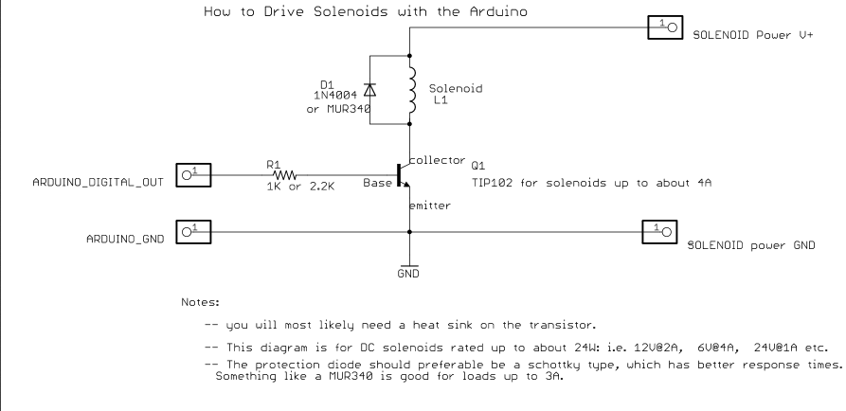

Figure 3.9 The schematic of solenoids with Arduino connections [6]

#### Block Diagram and Flow Chart

As can be seen in Block Diagram in Figure 3.10., Dc to Dc converter is used for upgrading DC voltage to hit the ball with more voltages. Also Flow Chart of shooting system can be seen in Figure 3.11.

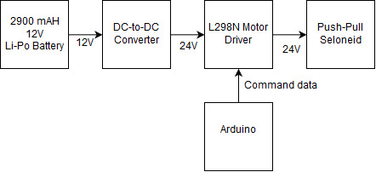

Figure 3.10 Block Diagram of Shooting System

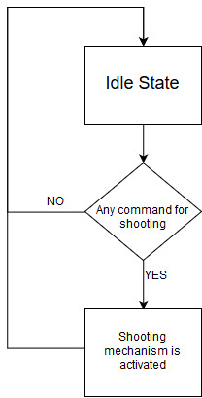

Figure 3.11 Flow Chart of Shooting System

### Motion Subsystem

#### Solution Approach

Motion subsystem consists of motors for driving the robot on the play field, wheels, other assembly parts such as encoders and gearboxes attached to these motors and also driver IC which converts inputs from the Main Processor Subsystem into meaningful inputs for the hardware part of the motion subsystem. Motion subsystem also sends feedback to Main Processor Subsystem.

We chose to implement our motion subsystem via a DC motor as in Figure 3.12., with the following specifications in Table 3-3:

Table 3‑2 DC Motor Specifications

|  |  |
| --- | --- |
| Dimensions | 37D x 102L mm |
| Weight | 310 g |
| Nominal Operating Voltage | 12V |
| Free run speed at 12V | 120 rpm |
| Free run current | 400 mA |
| Stall torque | 25 kg.cm |
| Gearbox ratio | 60:1 |

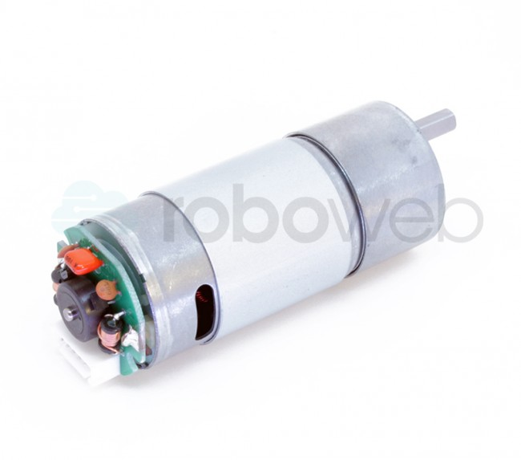

Figure 3.12 RW-ML-1333 DC Motor

In order to drive these two DC motors, we are using L298N which is our main solution as a motor driver as mentioned in the Conceptual Design Report. The L298N is a dual H-Bridge motor driver which allows speed and direction control of two DC motors at the same time. The module can drive two DC motors that have voltages between 5 and 35V, with a peak current up to 2A. We will drive two DC motors using this IC with respect to the pin connections as seen in Figure 3.13.

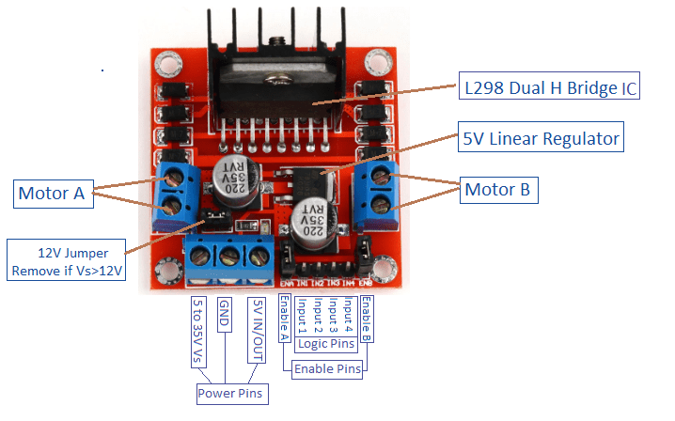

Figure 3.13 Pin Connections of L298N Driver IC

L298N motor driver uses PWM as input to adjust the speed of the motors by changing the duty cycle. 100 % duty-cycle means full throttle and 0 % duty-cycle means zero-velocity. We are using an Arduino Mega on the robot side which creates these PWM signals with respect to the commands sent from the controller side. We are not implementing speed control directly from the controller side. However, we are implementing smooth start and brake strategies in order to prevent high peak current at the start of the motion and also to protect the mechanics of the DC motors. We can also set the turning direction of the motors by simply setting two pins for each motor either HIGH-LOW or LOW-HIGH. These four pins can be seen in Figure 3.13. as the Logic Pins. This direction control is used for differential drive of the robot which was also mentioned in the Conceptual Design process.

After deciding on our DC motor, we needed to choose an encoder to give feedback to the Main Processor Subsystem. This feedback is vital since even though both of the DC motors are identical there may be a calibration difference between them. Our robot may deviate from its straight path. Therefore, we need to calibrate these two motors by implementing optimization with respect to the encoder counting differences.

Incremental encoders are useful for our purpose. The encoder type we are using, has Hall-effect sensor in it and counts up to 44 for one single turn but it should be multiplied with the gear ratio. Hall effect encoders use magnetic phased arrays that contain hall sensor elements arranged in a pattern to match a magnetic wheel. A signal is produced as the sensor passes over the magnetic field which is then interpolated to the desired resolution. The representation is as in Figure 3.14..

 For wheels we are using two standard wheels and also three ball wheels to stabilize the robot chassis. Wheels-chassis integration is covered in the technical drawings part.

Figure 3.14Magnetic Encoder Representation with Hall-effect Sensor

#### Block Diagram and Flowchart

Block diagram of the motion subsystem can be seen in Figure 3.15..

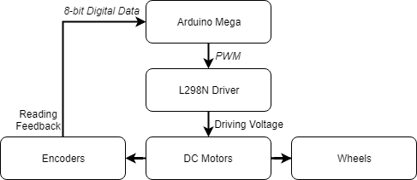

Figure 3.15 Block Diagram of the Motion Subsystem

Flowchart of the motion subsystem can be seen in Figure 3.16..

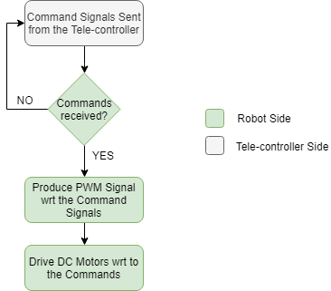

Figure 3.16 Flowchart of the Motion Subsystem

### Detection Subsystem

The main aim of the detection subsystem is to create a field vision for the teleoperator. Since this subsystem is the only source of information for the teleoperator, it must gather all the important data around the robot. This system must gather lots of visual data with minimum delay.

To design most suitable solution for detection unit, we decided to use a on board camera attached to the robot. Since the video data contains most of the valuable information the teleoperator needs, we decided to use an onboard camera for visual input. After obtaining the video input from the camera, the current frame of video is directly transferred to the telecontroller subsystem by communication subsystem without any processing. The transferred data is streamed on an LCD screen for telecontroller.

Due to the competitive nature of this project, the delay between teleoperator and visual of playfield must be as short as possible. To decrease delay time caused by detection subsystem, this system directly sends the raw video data without any processing. The block diagram and flowchart of detection subsystem can be observed in Figure 3.17. and Figure 3.18. respectively.

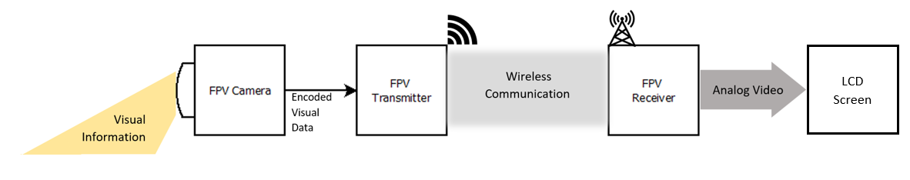

Figure 3.17 Block diagram of Detection Subsystem

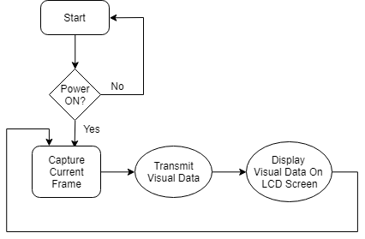

Figure 3.18 Flowchart of Detection Subsystem

As observed in figures provided, in the first step camera captures the real time visual information about the playfield. This visual information is encoded for the transmission and send directly to the receiver via RF channel. The transmitted information does not have any processing on it, due to the timing issues. The received real time video data is decoded and converted to the AV (Analog Video) format which is supported by our screen.

For the data transfer we use AKK KC03 800TVL NTSC Switchable Camera Module, shown in Figure 3.19., since it has a built-in transmitter, which we are going to use in communication subsystem. This camera module provides high quality video output for the telecontroller.

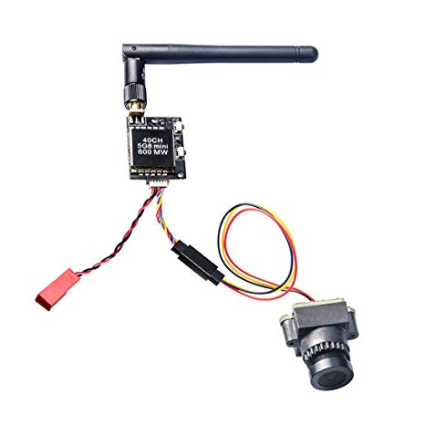

Figure 3.19 AKK KC03 800TVL NTSC Switchable Camera Module 600mW FPV Transmitter

### Main Processor Subsystem

#### Solution Approach

Our plan for main processor subsystem is to use Arduino Mega. Figure 3.20 below shows an Arduino Mega.

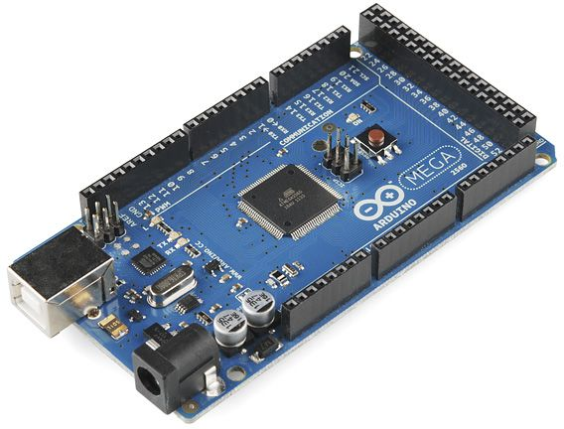

Figure 3.20 Arduino Mega [7]

Our main plan is to use Arduino Mega for main processor subsystem it is chosen because it has variety of I/O pins which makes it possible for us to use only one processor for robot side. Also, Arduino has a variety of online sources that are easily reachable which makes it easier to program. Arduino MEGA will used to control motors, shooting system motor and command receiver module on robot side.

We are going to use an Arduino UNO in the tele controller side as a processor. The reason why we use UNO instead of MEGA in tele controller part is that we do not need higher DC current or higher number of pins that MEGA offers in tele controller part. Figure 3.21. below shows an Arduino UNO.

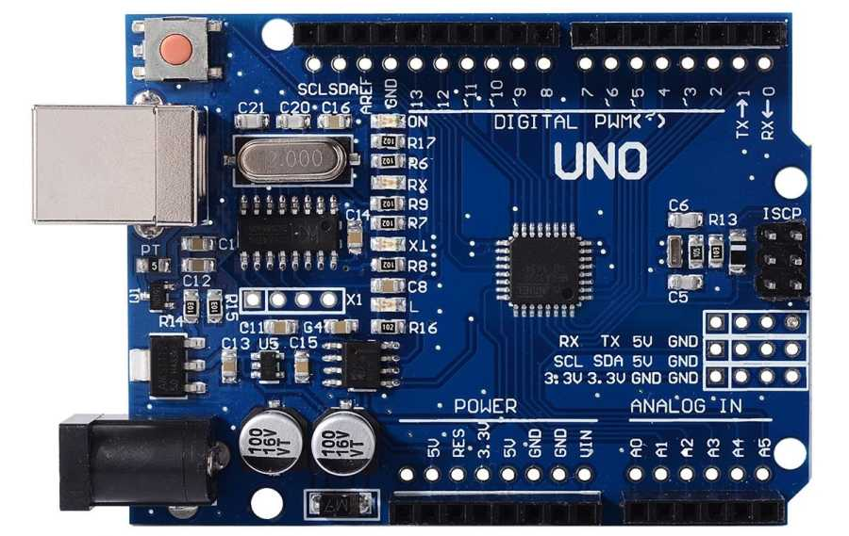

Figure 3.21 Arduino UNO [7]

Arduino UNO will used to control the joystick commands, command transmitting module and video receiving module on tele controller side.

#### Block Diagram & Flow Chart

Figures 3.22-23 below shows block diagrams for main processor subsystem. Signal interfaces are clearly labeled.

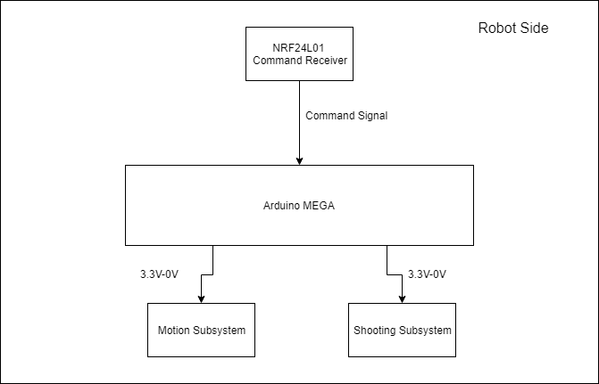

Figure 3.22 Block diagram of processor system at robot side

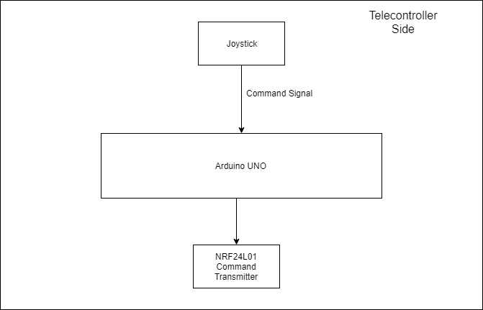

Figure 3.23 Block diagram of processor system on telecontroller side

Figure 3.24 below shows a flow chart for both of the processor system.

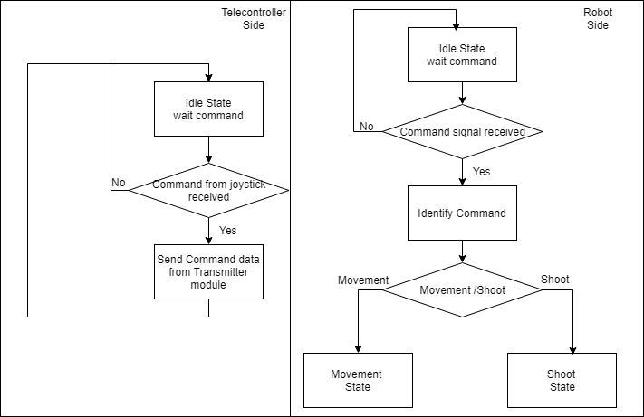

Figure 3.24 Flow chart for main processor subsystem

## System Level Block Diagram & Flowchart

Block diagram of the overall system can be divided into two parts. First one is the Controller Side and the second one is Robot Side. Block diagrams of these two parts can be seen in Figure 3.25 and Figure 3.26.

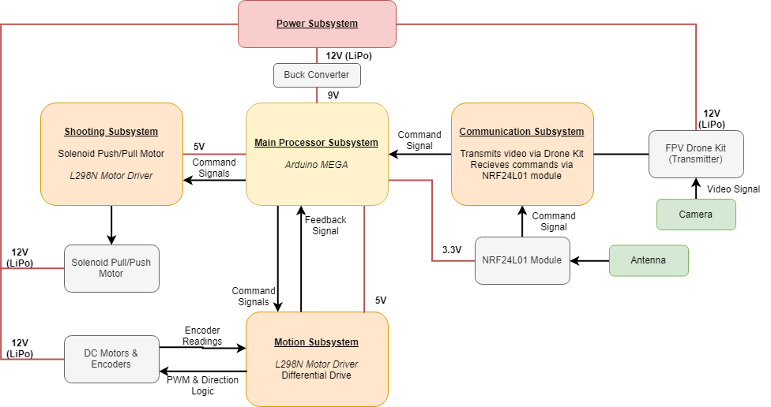

Figure 3.25 Block Diagram of the Overall System (Robot Side)

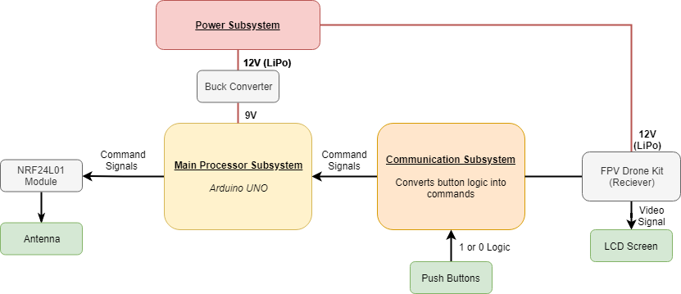

Figure 3.26 Block Diagram of the Overall System (Controller Side)

Flowchart of the overall system can be seen in Figure 3.27..

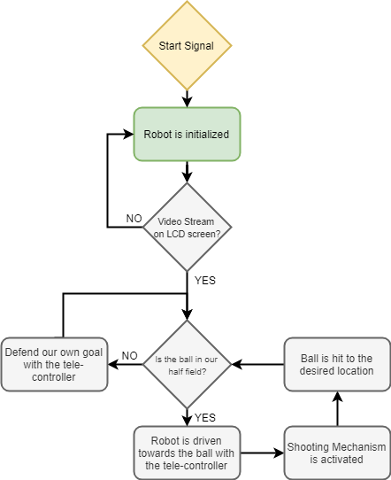

Figure 3.27 Flowchart of the Overall System

# Requirements

The goal of this project is to design and construct a teleoperated robot (controlled from a distance up to at least 30 meters) which can compete with a similar robot in shooting and scoring to opponent’s goal. Functional, physical and performance requirements of the system and subsystem levels are as follows:

## Overall System Requirements

Functional, physical and performance requirements of overall system converge all the subsystem requirements. These requirements are as follows:

**Functional requirements:**

* Detect the start signal
* Monitor the surrounding
* Process the monitored data
* Encode the processed data for communication
* Transfer the encoded data to the teleoperator

*If the ball is at players half-field and far away from the robot:*

* Transfer the movement direction command given by the teleoperator, to move toward the ball
* Perform the move operation respect to the command transferred from teleoperator
* Move robot to the ball until ball is in the shooting range
* Transfer the hit the ball command given by the teleoperator
* Perform the hit the ball operation given by teleoperator

*If the ball is at opponent’s half-field:*

* Transfer the movement direction command given by the teleoperator, to cover the goal, given by the teleoperator
* Perform the move operation respect to the command transferred from teleoperator
* Move robot to the own goal to protect it from the incoming shoot
* Protect the goal respect to the commands from teleoperator

**Physical requirements:**

* Goals must be at least twice as wide as their defenders’ lateral dimensions.
* Robots can hit, push or otherwise drive the ball but not grasp, scoop or otherwise carry it. So, robot cannot have a grasping or scooping part.
* The playfield should be regular hexagon on a bare floor, with center-line and goal lines marked by “masking tape”.
* The playfield constructed from 6 sidewalls of 70-75 cm length each and two goals snugly fit at the opposite corners, while preserving symmetry.
* The robot should fit in a 40 cm diameter cylinder.
* In order to move fast enough our motors should carry the weight of the remaining parts.
* Weight should be aligned in center for steady and controllable movement.
* Robot should be less than 3 kgs in total.
* Shooting plate should be larger than the dimensions of ball.
* The ball should not move under the robot in any condition so the distance between robots first stage and floor should be less than 5 cm.

**Performance requirements:**

* Ball should be transferred to opponent’s half-field in no more than 20 seconds.
* The operator remotely controls the robot from a distance up to at least 30 meters indoor.
* The transmission delay between the robot and receiver should be less than 0.5 seconds.
* The robot should be able to work with at least 2 kg load.
* The robot’s shooting mechanism should be strong enough to throw the ball to opposing goal with one push from its own goal area.
* Robot should move from one end to half field in last than 3 seconds.
* Detection subsystem should be able to work in different lightning conditions.
* Main processors operate different operations in parallel.
* All system should work more than 15 minutes without the need of battery charging.

## Subsystem Level Requirements

Different subsystems of the project have different requirements. This section of the report covers these requirements.

### Power Supply Subsystem Requirements

Functional, physical and performance requirements for power supply subsystem is as follows:

**Functional Requirements:**

* Power supply subsystem should supply power to all other subsystems.
* Required different voltage and ampere values should be generated by power supply subsystem.

**Physical Requirements:**

* Power supply system at the robot side should be less than 250 gr.
* Power supply system at the controller side should be less than 80 gr.
* Battery in the controller side should fit in a box with dimensions 80x25x25mm.
* Battery in the robot side should fit in a box with dimensions 40x50x25mm.

**Performance Requirements:**

* Both power supply system at the robot side and the controller side should supply 5V and 12V.
* The temperature of batteries should not reach 60⁰. [8]
* Controller side should not draw more than 5A in order to have operation approximately 10 minutes. To operate the system more than 15 minutes the power system should supply less than 3.6A. [9]
* Robot side should not draw more than 15A in order to have operation approximately 10 minutes. To operate the system more than 15 minutes the power system should supply less than 10A. [2]

### Communication and Telecontroller Subsystem Requirements

Functional, physical and performance requirements for communication and telecontroller subsystem is as follows:

**Functional Requirements:**

* Detect the start signal.
* Monitor the surrounding.
* Process the monitored data.
* Encode the processed data for communication.
* Transfer the encoded data to the teleoperator.
* Transfer the movement direction command given by the teleoperator, to move toward the ball.

**Physical Requirements:**

* The weight of communication and telecontroller subsystem at the robot side should not exceed 250gr.
* Individual elements of this subsystem should fit in a box with dimensions 110x60x50mm. (The element which has the maximum volume is Arduino MEGA so the others should be smaller than Arduino MEGA.) [3]

**Performance Requirements:**

* The transmission between the robot and receiver should be less than 0.5 seconds.
* The operator remotely controls the robot from a distance up to at least 30 meters indoor.

### Shooting Subsystem Requirements

Functional, physical and performance requirements for shooting subsystem is as follows:

**Functional Requirements:**

* The subsystem should be able to push the ball with the shoot signal.

**Physical Requirements:**

* Shooting plate’s height should not be higher than 6 cm in order to not exceed first floor of the robot.
* The weight should be less than 100 gr.
* Shooting plate should be larger than the dimensions of ball.

**Performance Requirements:**

* The robot’s shooting mechanism should be strong enough to throw the ball to opposing goal with one push from its own goal area.

### Motion Subsystem Requirements

Functional, physical and performance requirements for motion subsystem is as follows:

**Functional Requirements:**

* This subsystem should perform the move operation respect to the command transferred from teleoperator.
* Robot should move towards the ball until ball is in the shooting range.
* Robot should move towards its own goal to protect it from the incoming shoot.

**Physical Requirements:**

* The weight of total subsystem should be less than 1000 gr.
* Individual elements of this subsystem should fit in a box with dimensions 120x60x100mm.

**Performance Requirements:**

* Robot should move from one end to half field in last than 3 seconds.
* Motors should carry at least 2 kg weight while satisfy other requirements.
* This subsystem should not drive more than 4A. (2A for each motor)

### Detection Subsystem Requirements

Functional, physical and performance requirements for detection subsystem is as follows:

**Functional Requirements:**

* Robot should monitor the surrounding.
* Robot should transmit the surrounding data.

**Physical Requirements:**

* The weight should be less than 100 gr.

**Performance Requirements:**

* Detection subsystem should be able to work in different lightning conditions.
* Detection subsystem should transmit data with less than 0.5 seconds delay.

### Main Processor Subsystem Requirements

Functional, physical and performance requirements for main processor subsystem is as follows:

**Functional Requirements:**

* This subsystem should be able to control the other subsystems with the same processor.

**Physical Requirements:**

* The weight should be less than 50 gr for both robot side and controller side.

**Performance Requirements:**

* Main processors operate different operations in parallel.

# Design Modifications and Justifications

Designing our robot, we made a few changes from the Conceptial Design Report. We will be explaining changes in subsystem level.

## Power Subsystem

In power subsystem, considering weight and necessity of powerbank, we decided to continue with step up/step down DC to DC converters. Comparing these modules(see Figure 5.1), they only weighs about 30-50 grams while a powerbank weighs more than 300-400 grams. As mentioned in individual description of power subsystem, we implemented step down converters for Arduinos. These converters reduced the total weight of robot by discarding the powerbank. In this case, we only need sole LiPo battery to power all subsystems on the robot. Motors, shooting selenoid and video transmitter is directly connected to LiPo (12V) and Arduinos are powered by these DC to DC converters.

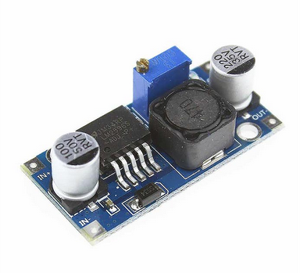

Figure 5.1 Step-up & Step-down converter module

In the overall system (robot and telecontroller), we have 12V 2900 mAh Lipo battery on the robot and 12V 900 mAh LiPo battery on the telecontroller.

## Telecommunication Subsystem

In the telecommunicatiıon subsytem, we made complete change in command sending system while keeping the video sending system the same.

For command sending system, we needed to change whole design presented in Conceptial Design Report due to legality issues. In the design described in Conceptual Design Report, we were using commercial FM radio frequencies (88 MHz-108MHz). However, according to BTK (Information Technologies Institution), civilians can not exceed RF power broadcast of 50 nW between this band[n]. We were using RF power level of 10 uW. So, we gave up on the system and developed a new system for command sending part of the telecommunication subsystem. We decided to use NRF24L01 RF tranciever modules for this purpose. The module uses 2.4 GHz frequency with its own protocol. The module is controlled by arduino interface. Setting up and testing the modules using procedures described in test procedures, we saw that the modules do satisfy our metrics. Test results are given in Table 5-1.

Table 5‑1 Command sending system error rate

|  |  |  |  |  |  |  |
| --- | --- | --- | --- | --- | --- | --- |
| Distance (m) | 7 | 14 | 21 | 28 | 35 | 42 |
| Data Loss (bits) | 0% | 0% | 0% | 9% | 15% | 22% |

Observing Table 5-1, we concluded that the modules can provide us a proper operation for our robot.

For video sending systems, we only changed the antenna with high quality ones. With the new antennas, the operation range improved and became acceptable for our use. The test results given in Table 5-2 justifies the operation.

Table 5‑2 Video quality test results

|  |  |  |  |  |  |  |
| --- | --- | --- | --- | --- | --- | --- |
| Distance (m) | 7 | 14 | 21 | 28 | 35 | 42 |
| Video Quality | Perfect | Perfect | Perfect | Perfect | Flickery | Flickery and Noisy |

Evaluating overall telecommunication subsystem, the whole system draws reasonable current, about 1.5 A, which is deliverable by a LiPo battery.

## Shooting Subsystem

In shooting subsystem, we needed to change to Plan B described in Conceptual Design Report which proposes a selenoid with a metal rod inside it. Because performing relevant tests, we saw that Plan A was not sufficient and the ball which is being shot could not be thrown at a certain distance. When we test both systems, the system in Plan A (which utilizes servo motor) can only achieve throw range of 10 cm while the system in Plan B (which utilizes selenoid) can achieve more than 1 meters. However, the selenoid draws more current than servo motor , about 800 mA, but this value is still within the range of deliverable current from a Lipo battery. Evaluating the results, we decided to use selenoid for shooting subsystem.

## Motion Subsystem

For motion subsystem, we stick with the plan A described in Conceptual Design Report which utilizes differential drive with two DC motors. Testing the motors, we evaluated that the speed and torque would be enough for a proper operation of our robot. Test results are explained in test procedures & results part.

## Detection Subsystem

In our design, detection subsystem contains a single element which is the camera. Camera obtains the image of the surroundings and directly sends the image data to the transmitter. Our camera has 120 degrees of field of view. For cameras, 120 degrees of field of view is considered as ultrawide angle camera. So, we decided that ultrawide angle camera is sufficient for our operation and thus, we implemented it. In addition, our cameras resolution and color depth are 720x480 and 24bits respectively. These numbers are perfectly suitable for our project since we only use it for imaging relatively short distances (<2m).

# Compatibility of subsystems

In the success of a system, compatibility of subsystems has a crucial role. Any error in the between subsystem end up with serious performance issues or even nonoperating system. In our system, there are two routes for information flow. These routes can be named, command transmission and visuals transmission, which is shown in Figure 6.1 and Figure 6.2 respectively.

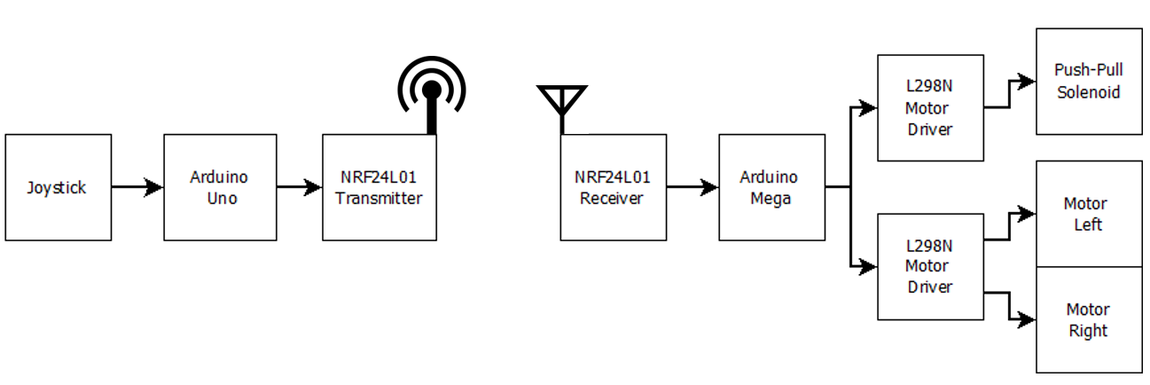  
Figure 6.1: The path of information flow in command transmission

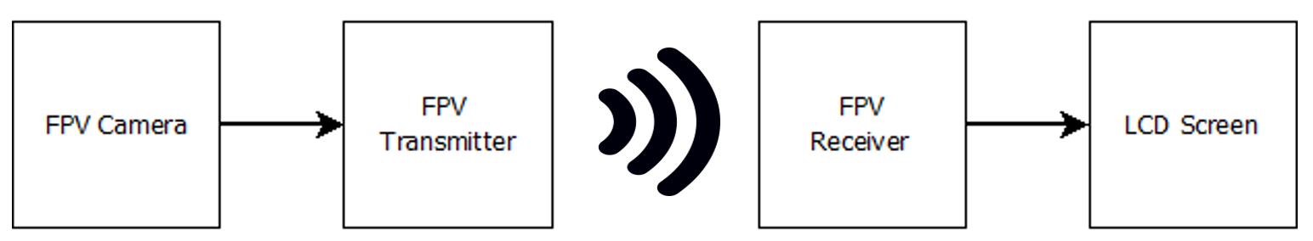  
Figure 6.2: The path of information flow in visuals transmission

As shown in the figures provided, this system designed to have two non-interacting information paths This separate design makes us able to implement these paths without any compatibility issue. If we investigate the signals in the path of command transmission:

* The analog signal created by joystick is read by analog pins of Arduino Uno.
* The processed command information is sent to NRF24L01 transmitter module with a protocol written by the developers of NRF24L01 for Arduino. Since this protocol is specially written for module and Arduino communication, fully compatible for our design.
* In this step wireless signal is send from NRF24L01 transmitter to NRF24L01 receiver. As these modules are identical and designed to be used together they are totally compatible.
* The received information is decoded by the protocol, stated in transmit step, in the Arduino. Since this protocol is specially written for module and Arduino communication, fully compatible for our design.
* The final command needs to be sent to motors. However, a direct interaction between Arduino and motors is impossible due to current and voltage limitations of Arduino. To solve this compatibility issue, we use L298N motor driver to make Arduino able to control motor with PWM signals.

If we investigate the signals in the path of command transmission:

* FPV camera records real time video and encodes this information into data packages by internal protocol. This packs can be directly sent to FPV transmitter since both components have hardwire connections and use same communication protocols.
* This encoded packs are transmitted to the FPV receiver. The transmission has no compatibility problem, since both transmitter and receiver are from the same module and designed to work together.
* The received data packs are decoded by internal algorithm in FPV receiver. This decoded data is converted into analog video format.
* Our LCD screen has a build in analog video input, which can stream the incoming video data without any problem.

# Test Procedure

## Power Supply Subsystem

For capacity measuring, we test motors by continuously driving and our robot could run for 30 minutes. This duration satisfies our requirements. Also, power measurement test is made for each components of our robots. The results can be seen in “Power Analysis of Robot” part.

## Telecommunications Subsystem

For our final design, we followed following test procedure for command sending subsystem: performing command sending quality with certain ranges. We measure data loss per 100 commands. Simply comparing the values we obtained bit error rate. Obtained results are given in Table 7-1.

Table 7‑1 Bit error rate versus distance between modules

|  |  |  |  |  |  |  |
| --- | --- | --- | --- | --- | --- | --- |
| Distance (m) | 7 | 14 | 21 | 28 | 35 | 42 |
| Data Loss (bits) | 0% | 0% | 0% | 9% | 15% | 22% |

## Shooting Subsystem

The ball was located in front of the shooting system and the ball was kicked with different voltages. The results can be seen in Table 7-2.

Table 7‑2: Throw distance versus supplied voltages of solenoid

|  |  |  |  |  |  |  |
| --- | --- | --- | --- | --- | --- | --- |
| Distance (m) | 0.00 | 0.20 | 0.25 | 0.35 | 0.60 | 1.10 |
| Supplied voltage (V) | 10 | 12 | 16 | 18 | 20 | 24 |

## Motion Subsystem

We executed following test procedures so far:

First of all we drove our DC motors for no-load condition to observe the amount of current it draws. A single DC motor draws 400 mA as mentioned in its datasheet. However, once we integrated the motors on our chassis and observed the amount of current drawn from both of the motors, we saw that it can exceed 2 A. This is because DC motors draw huge amount of current at the start of the motion. In order to prevent these high current peaks we are implementing soft start strategies. This is implemented by software. We will increase the speed incrementally.

We did further tests on the speed of the vehicle with 100% throttle. Considering the length of the half playfield and the time our robot to measure the approximate speed of the robot. The velocity of our robot is approximately 0.45 m/s. Since this velocity is highly enough to satisfy the 20 sec restriction we can consider lowering the speed to increase efficiency of the battey usage.

In addition to these test results we are planning to do tests on speed optimization mentioned above. These adjustments will make our robot more stable and decrease the mechanic strain on the DC motors. We will implement these tests in the playfield.

## Detection Subsystem

The subsystem test of detection subsystem is designed to detect any possible malfunction on the real time video stream.

**Screen test:** The LCD screen must stream all incoming analog video information. To check functionality of the LCD screen, we connect external AV video input to the screen. The screen must show all frames of the input video without any pixel error.

**Video stream test:** This test is designed for controlling the functionality of camera. The test will be performed with all elements of subsystem are activated in a controlled environment (no other active video module around), with transmitter and receiver modules located 15 cm apart. During the test quality and delay of the video stream is measured independent from environmental effects.

**Communication channel test:** The main aim of this test is controlling the communication channel we are using. Our communication channel can communicate on different channels, which gave us great flexibility if any other signals are present. For this test we only activate receiver and LCD screen. Without any broadcast from our transmitter, we only listen other channels and test the availability of the channels. The occupied channels need to be avoided since they decrease the quality of our signal and visual data. The channels with minimum noise must be chosen at the end of this test.

**Range test:** After all the previously tests are done, the last test must be performed. In the range test, the camera and transmitter are slowly driven apart from receiver and screen, until the video stream on screen become fuzzy. If the video protects its quality more than 30 meters indoor, this test is successful.

## Main Processor Subsystem

Main processor subsystem only consists Arduino’s so for this subsystems test procedure the only thing that should be tested is the operations of Arduino’s.

**Power Test:** Power test will be conducted under different voltage supplies. At the end we won’t supply Arduino’s from computer or powerbanks so Buck converter output should be connected to Arduino to test the operations. If it is turning on this test will be successful. We tried it with power supply and it turned on, so this test resulted successfully.

**Simultaneously Parallel Operation Test**: Since we want the work different operations in parallel, a test should be conducted while shooting, motion and receiver modules are connected. All of them worked successfully during the test, so result is successful.

# Compliance with Requirements

## Design Decisions and Requirement Correlations

Requirements are given in section 4 of this report.

* As our main processor we selected Arduino MEGA on robot side in order to do operations is parallel. As mentioned in one of our performance requirements is to work different operations simultaneously and parallel. Since Arduino MEGA has 54 Digital I/O pins and 16 Analog Input pins [4]. Also, Arduino MEGA offers higher speed than its components.
* We designed two story robot body in order to comply with the requirement that is the robot should fit in 40 cm diameter cylinder. This requirement is decided by our company to create a smaller robot body which results smaller goal.
* The motors are connected on top of the first stage of the robot to comply the physical requirement that the ball should not pass under our robot.
* We designed our shooting plate approximately 8*5 cm to comply the requirement that the shooting plate should be bigger than the ball.
* We designed our robot to comply with the requirement that weight is aligned in the center. In robot we have 2 motors, 2 motor drivers they aligned symmetrically, and other elements are aligned at center.
* Since in requirements it is stated that it is not allowed to grasp, pull etc. we decided to have a pushing shooting system.
* We used NRF24L01 RF module since its compatibility with Arduino, cost and range performance. It is easy to implement; very low cost and it provides enough range for our operation.
* In order to satisfy 20 sec restriction, we had to choose a DC motor and wheel integration which will drive our robot from one end of the field towards the half field less than 3 sec. Therefore, we chose a satisfactory motion system integration so that it takes approximately 1.6 sec to reach half field from the furthest corner.
* To comply with the power requirements, at telecontroller side we are going to use 900 mAh Li-po battery. This battery is going to give telecontroller approximately 30 minutes of operation. Because during our tests video receiver and command transmitting module approximately draws 1.5A. So, this result complies with the requirement that system should work more than 15 minutes.
* To comply with the power requirements, at robot side we are going to use 2900 mAh Li-po battery. This battery is going to give robot approximately 40 minutes of operation. Because during our tests video transmitter, command receiver, motion subsystem and shooting subsystem module maximum draws 3.5A. So, this result complies with the requirement that system should work more than 15 minutes.

## Conflicting Requirements and Trade-offs

* We are using Li-po batteries which are heavy parts and increases the weight of our robot and telecontroller but they comply the power requirements.
* Arduino MEGA has more than 50 pins and faster response but on the other hand it is one of the most expensive items of our robot. We considered cost as a requirement in that case.
* Our motors comply the speed and torque requirements, but these motors are heavy and big parts. The length of one motor with wheel is approximately 10 cm so these motors limits our body diameter.
* Our video transmitter is small and transmission power is high which complies the requirement on the other hand the temperature increases so it needs heatsink and fan which add weight to our system.

## Discussion on Robustness

We used plexiglass material for the body of our robot which is durable material. All the elements are attached permanently to the body so, robot structure is not going to be affected by outside sources. All the cables are attached to the body to avoid cluttering. We are using Arduino programming which is easy, and our code does not have any errors because this code is used by other user throughout the time. This open source code has lower change to have an error. Power system has a switch and it is detachable for easy use. For testing 10 times doing the same operation our robot gave the same response every time. We made hardware tests and each element gave consistent response. To avoid overheating we placed fans and heatsinks, so our robot is not going to be affected by temperature changes.

# Resource Management

## Cost Analysis and Breakdown

**Motors**

Since the dimensions of the field is not too large, there is not so much space for our robot to freely move. In order to create precise movement motors of the robot must have a high torque and low RPM. Brush DC motor with gearbox is most suitable option among other option on both performance and price level. Hence, we use DC motor with gearbox for movement. With this decision we spent 22% of our budget on motors.

**Development boards**

In the market, development board options are countless. For every application, there are dozens of options with very large performance and price range. In our case, the need for computational power very low. On the other hand, speed is very critical which eliminates high performance complex boards like Raspberry Pi or Intel series. For our operation Arduino family is more suitable since, the design is mature, IDE is well designed and have a great community and prices in our range. Moreover, the clone series especially decrease the prices, which create a great advantage for us. Hence, we decided to use less capable Clone Arduino Uno for telecontroller and high-performance Arduino Mega for robot. With the introduction of clone modules, development boards only hold 7% of our budget

**Communication**

The quality and reliability of communication between robot and telecontroller has a crucial importance in the success of this project. To ensure the robot performs under in desired circumstances without any error, we set our communication budget as high as possible.

Video transmission is especially challenging due to size of the data. Despite its relatively high price, the video quality and transmission range are far better than other options. Hence, we choose FPV drone module among other options.

Command transmission is comparably easy, since we deal with smaller size command data. Hence, we prefer a cost-effective module, NRF24L01. For these two modules we spent 22% of our budget.

**Power**

The power network of this project is carefully designed to powerup all the components until the end of the operation. Also, the weight of the batteries is another issue. We decided to use Li-Po batteries (one for each side) with step-down converters to create a lightweight solution within our budget. This power system cost us 19% of our budget.

Table 9‑1 Revised cost breakdown

|  |  |  |  |
| --- | --- | --- | --- |
| **Materials** | **Quantity** | **Price per each** | **Total Price** |
| **Motors** |  |  |  |
| DC Motors | 2 | $10 | $20 |
| Gearbox | 2 | $5 | $10 |
| Encoders | 2 | $5 | $10 |
| L298N Motor Driver | 2 | $1.5 | $3 |
| **Development Boards** |  |  |  |
| Clone Arduino Uno | 1 | $4 | $4 |
| Clone Arduino Mega | 1 | $10 | $10 |
| **Shooting** |  |  |  |
| Push-Pull Solenoid | 1 | $4 | $4 |
| **Communication** |  |  |  |
| FPV Drone Kit | 1 | $35 | $35 |
| NRF24L01+PA+LNA SMA | 2 | $4 | $8 |
| **Telecontroller** |  |  |  |
| Joystick | 1 | $0.50 | $0.50 |
| LCD screen | 1 | $30 | $30 |
| **Power** |  |  |  |
| 900 mAH Li-Po Battery | 1 | $14 | $14 |
| 2900 mAH Li-Po Battery | 1 | $20 | $20 |
| Buck Converter | 4 | $1 | $4 |
| **Structural** |  |  |  |
| Plexiglass Chassis | 1 | $6 | $6 |
| Standard Wheels | 2 | $2 | $4 |
| Ball Wheel | 3 | $1 | $3 |
| Cables & Connectors | nAn | $6 | $6 |
| 3D Printed Parts | nAn | $2 | $2 |
| Structural connections | nAn | $3 | $3 |
| **Demo Setup** |  |  |  |
| Dummy Robot | 1 | $2 | $2 |
| Balls | 2 | $0.25 | $0.5 |
| Play Field Walls | 3 | $1 | $3 |
|  |  |  |  |
| **Total:** |  |  | **$199** |

## Power Distribution Analysis

In the development of battery powered projects, the power analysis has a crucial role. In our project we have a not one, but two battery powered parts to design and develop. Since the batteries are the only power source our robot and telecontroller has, to ensure proper operation for a predetermined time the power analysis must be done carefully.

In the first step of the power analysis, a distribution scheme for both parts are prepared. This connection schemes for robot and telecontroller can be observed in Figure 9.1 and Figure 9.2 respectively.

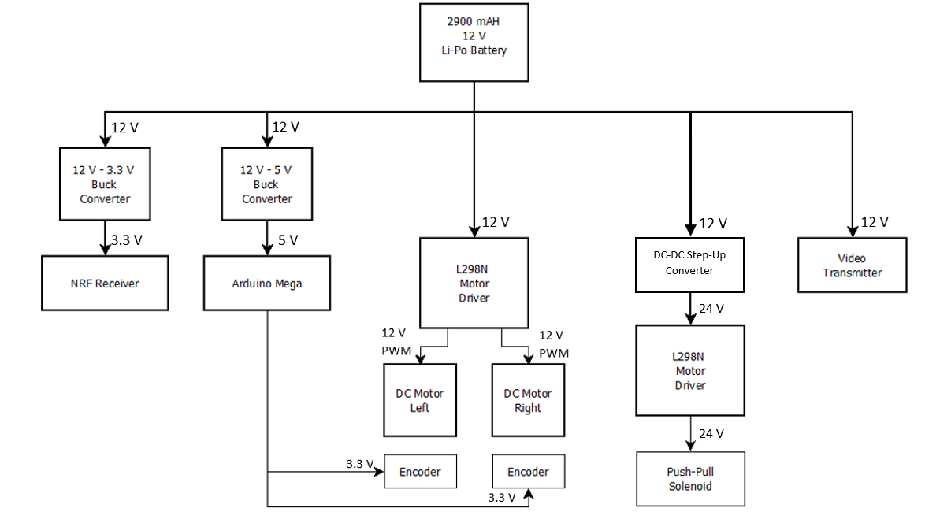

Figure 9.1 Power distribution scheme for Robot

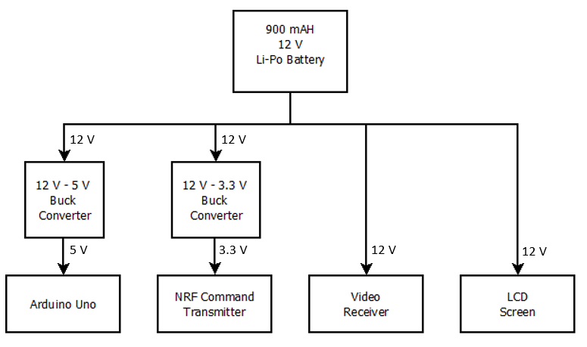

Figure 9.2 Power distribution scheme for telecontroller

In the total power consumption calculation of the system, we considered the worst-case scenario of each design element separately. Despite, this analysis method overestimates the power consumption, it creates a safety margin for us. In the case all the systems are active and at their full power, our system is going to be still fully functional. The power analysis of robot and telecontroller can be observed in Table 9-2. and Table 9-3 respectively.

Table 9‑2 Power analysis of Robot

|  |  |  |  |  |  |
| --- | --- | --- | --- | --- | --- |
| Device | Quantity | Maximum Values per Device | | | Total Device Power |
| Current | Voltage | Power |
| DC Motor | 2 | 300 mA | 12 V | 3.6 W | 7.2 W |
| Drone Transmitter | 1 | 400 mA | 12 V | 4.8 W | 4.8 W |
| Push-Pull Solenoid | 1 | 250 mA | 24 V | 6 W | 6 W |
| NRF24L01 Receiver | 1 | 100 mA | 3.3 V | 330 mW | 0.33 W |
| Arduino Mega | 1 | 100 mA | 5 V | 500 mW | 0.5 W |
| **Total Power** |  | | | | **18.83 Watt** |

Table 9‑3 Power analysis of Telecontroller

|  |  |  |  |  |  |
| --- | --- | --- | --- | --- | --- |
| Device | Quantity | Maximum Values per Device | | | Total Device Power |
| Current | Voltage | Power |
| Drone Receiver | 1 | 10 mA | 12 V | 120 mW | 0.12 W |
| Screen | 1 | 400 mA | 12 V | 4.8 W | 4.8 W |
| NRF24L01 Transmitter | 1 | 100mA | 3.3 V | 330 mW | 0.33 W |
| Arduino Uno | 1 | 100 mA | 5 V | 500 mW | 0.5 W |
| **Total Power** |  | | | | **5.75 Watt** |

## Gantt Chart

Gantt Chart of Potato Integrated Technologies can be found in Figure 9.3..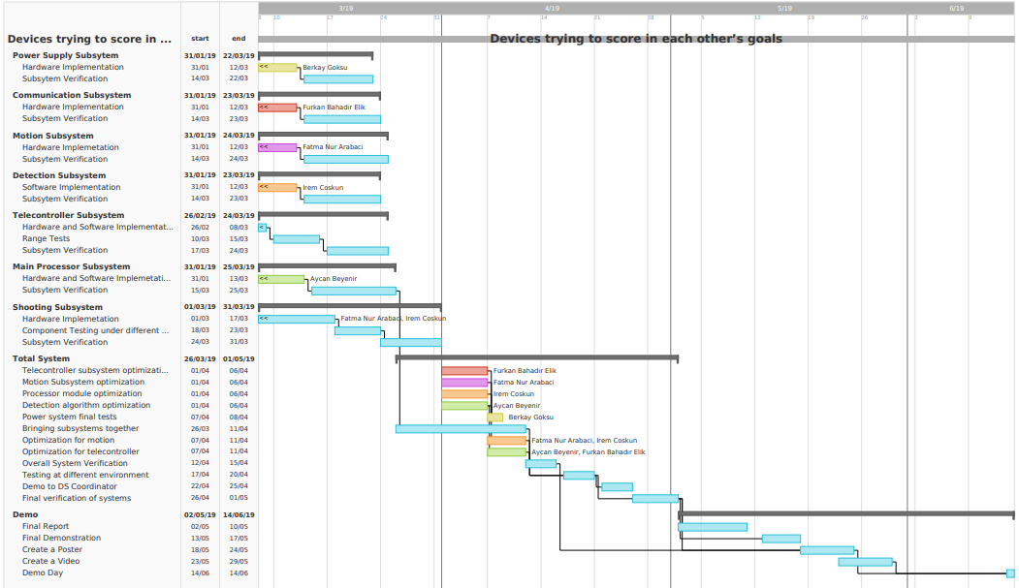

Figure9.3 Gantt chart of PITech

# Conclusion

The main focus of this critical design report is to ensure that the system under review can proceed into system fabrication, demonstration, and test; and can meet the stated performance requirements within cost (budget), schedule, and other system constraints. In this report we presented our system design for the previously stated problem, “Devices Trying to Score in Each Other’s Goals”, namely a robot that communicates with the controller and via remote operator, tries to score on opponent’s goal. We changed some of our previously stated in ideas in conceptual design report and these design modifications described with clear justifications.

Detailed requirements for both system level and subsystem level were presented in this report with top-down approach. Also, justification of the parts that are not modified was given with the justifications to satisfy the customer and engineering requirements. In addition to that test results, encountered problems and proposed solutions are presented.

Compatibility analysis of sub-blocks are discussed, and signal interfaces are clearly described. This report also includes the correlation between the requirements and decisions. At the end of the report we presented our modified cost analysis, modified and up-to-date Gantt Chart. A power distribution diagram and power management analysis were also provided.

To conclude, this report contains all the parts of our design with clear justification. We are planning to implement this design without changing the essential parts of the system design. Our main goal is using the most practical and simple solution that would not create redundant complications for this product is to be used in various real-life applications. So, we Potato Integrated will deliver an exceptional final product together with the deliverables, within a short timeframe and economic budget. Our aim as an ambitious company to thrive on everyday problems with topnotch products with performance and durability.

As PITech engineers, we tried to find the best solution within $200 budget that will fulfill the requirements and satisfy the customer. This report is to shows that our system under review can proceed into system fabrication, demonstration, and tests. We are confident and showed that our design meets the stated performance requirements within cost (budget), schedule, and other system constraints.

# References

[1] Figure 3.1 Retrieved from <http://www.helipal.com/storm-11-1v-2200mah-35c-pro-series-li-po-battery-xt60.html>.

[2] Figure 3.2 Retrieved from [tronixlabs.com.au](https://tronixlabs.com.au).

[3] NRF24L01 Arduino Libraries. Retrieved from <https://github.com/nRF24/RF24>

[4] Mechatronic Design of a Soccer Robot for the Small-Size League of RoboCup. Retrieved from <http://mech.vub.ac.be/multibody/final_works/thesis_joris_de_witte.pdf>

[5] Figure 3.8 Retrieved from <http://www.mate.tue.nl/mate/pdfs/6971.pdf>.

[6] Figure 3.9 Retrieved from <https://pdf.direnc.net/upload/solenoid-driver-adafruit.pdf>.

[7] Store.arduino.cc. (2018). *Arduino Mega 2560 Rev3*. [online] Available at: <https://store.arduino.cc/usa/arduino-mega-2560-rev3>

[8] Here's all you should know about LiPo Batteries. (2019). Retrieved from <https://www.myrcbox.com/articles/tech-article-what-you-should-know-about-lipo-batteries/>

[9] Multicopter build log. (2019). Retrieved from <http://multicopter.forestblue.nl/lipo_need_calculator.html>